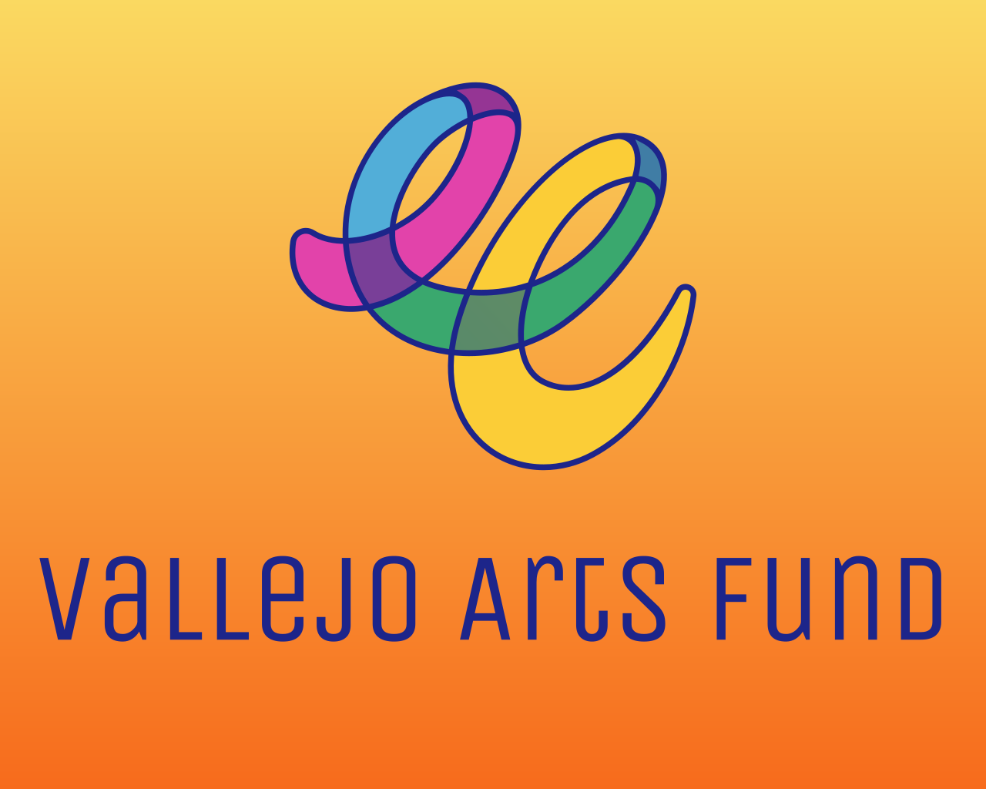
Places & Spaces Grant
Application Preview

The Places & Spaces Grant Application Preview is for REFERENCE ONLY.

The Vallejo Arts Fund will award up to nine grants, ranging from $5,000 to $20,000, with flexible funding terms of either one or two years, within the Places and Spaces category. Funding will be awarded to individuals, collectives, or organizations to support the costs associated with producing, using, and/or maintaining a physical space or place that enables artistic and/or cultural production in Vallejo, CA.

ELIGIBILITY QUIZ
- Are you 18 years or older?
- Do you reside full-time in California?
- Do you make art or engage in cultural community practices in Vallejo?
- If awarded a grant, are you able to provide proof of identity?
- Are you a Vallejo resident?
  - If yes – If awarded a grant, are you able to provide proof of Vallejo residency?
  - If no – If awarded a grant, are you able to provide proof of California residency?

SECTION 1: CONTACT INFORMATION & APPLICATION DETAILS
- Name of Collective/Organization (if applicable)
- Legal First Name of Lead Team Member or Individual Applicant
- Legal Last Name of Lead Team Member or Individual Applicant
- OPTIONAL: Other Names (e.g., Stage, Artist, Preferred, or Chosen Name)
- Pronouns of Lead Team Member or Individual Applicant
- Where do you live?
  - North Vallejo
  - East Vallejo
  - South Vallejo
  - West Vallejo
  - Downtown Vallejo
  - Mare Island
  - Outside of Vallejo/Other (Write-in)
    - If you selected “Outside of Vallejo/Other (Write-in Option)”, let us know where you live.
- Home address of Lead Team Member or Individual Applicant
- City
- Zip Code
- Lead Team Member Email Address
- Lead Team Member Daytime Phone Number
- Website URL
Note: Please provide a direct URL to the website or portfolio where your individual, collective, and/or organizational artistic and/or cultural works are prominently featured.
The link must be publicly accessible and clearly attributable to the applicant (individual, collective, or organization). We will not review password-protected or restricted links, links that require login access, or links to private drives (e.g., Google Drive, Dropbox, or OneDrive).
You may include links to a website, press coverage, artist databases (such as IMDb, Artsy, or SoundCloud), or public social media pages (like Instagram, YouTube, or Facebook). The URL must link directly to a page or post that features both your individual, collective, or organization’s work and name—for example, a specific project page rather than a general profile or homepage.
This link serves as proof of a public-facing artistic, creative, or cultural practice. If we are unable to verify the information provided, your application will be considered incomplete and ineligible for funding.
- Which discipline best describes your individual, collective, or organization’s primary artistic discipline or area of cultural production? (Select One)
  - Options: Animation; Dance; Design; Education; Folk/Traditional Arts; Humanities/Literary Arts; Media Arts; Multidisciplinary; Music; Musical Theatre; Opera; Social Practice; Theatre; Visual Arts; XR (AR/MR/VR).
- OPTIONAL: If the previous list did not fully reflect your individual, collective, or organization’s discipline or area of cultural production, please select the ones that do from the following list
  - Options: Arts Education; Book Arts; Ceramics; Conceptual Art; Craft; Dance; Design; Digital Technology; DJ-ing; Fiber and Textile Work; Fiction/Non-Fiction Writing; Film/Video; Folk and Traditional Arts; Folklore; Glasswork; Hip Hop; Literary Arts; Media Arts; Digital Media; Metalwork; Multidisciplinary; Multimedia; Mural Making; Music; Musical Theatre; Nonfiction; Storytelling; Opera; Painting; Paper and Printmaking; Performance Art; Photography; Poetry; Public Art; Quilting; Regalia Making; Sculpture; Social/Community-Engaged Practices; Spoken Word; Storytelling; Street Art; Theatre; Visual Arts; Woodworking; XR (AR/MR/VR); Write-In Option
    - Write-In Option: If you selected "Write-in Option" with regard to your individual, collective, or organization’s artistic discipline or area of cultural production, please describe. [25 words max]

SECTION 2: VALLEJO RESIDENCY AND ROOTEDNESS
Based on feedback and insights from Vallejoans, the Vallejo Arts Fund honors the importance of individuals, collectives, and organizations being residents of Vallejo and their “rootedness” within the community. The following section seeks to understand the applicant's history of engaging with, working in, and/or rooting their practice in Vallejo.

Please refer to the Rootedness Criteria in the FAQ for more information.

- How long have you been a resident of Vallejo, or has your collective/organization been based in Vallejo?
  - N/A- reside or are based outside of Vallejo
  - Less than six months
  - 6 months - 1 year
  - 1-3 years
  - 3-5 years
  - 5 - 10 years
  - 11+ years
- In which part of Vallejo does the majority of your rooted work take place?
  - North Vallejo
  - East Vallejo
  - South Vallejo
  - West Vallejo
  - Downtown Vallejo
  - Mare Island
  - Other (Write-in Option)
    - If you selected “Other (Write-in Option)”, let us know in which part of Vallejo the majority of your rooted work takes place.
- How long have you or your collective/organization been engaging with, working in, and/or rooting your practice within the Vallejo Arts and Cultural Ecosystem? How is your individual or collective/organization’s artistic work or cultural practice informed or impacted by your context in Vallejo? (300 words max)
- Provide a brief statement about the nature of your or your collective/organization’s work and practice in Vallejo, the kinds of relationships and/or engagement you have built, including collaborators and/or partnerships. Who and/or which communities have you worked with and/or are working with? Where is your work rooted/engaging/happening in Vallejo? (300 words max)

PLACES AND SPACES OVERVIEW
The Vallejo Arts Fund will award up to nine grants, ranging from $5,000 to $20,000, with flexible funding terms of either one or two years, within the Places and Spaces category. Funding will be awarded to individuals, collectives, or organizations to support the costs associated with producing, using, and/or maintaining a physical space or place that enables artistic and/or cultural production in Vallejo, CA.

- I am applying for:
  - Multiple-Year Grant (Grant Term: 2026 -2028)
  - Single-year Grant (Grant Term: 2026 - 2027)
- Are you applying as an individual or as a collective/organization?
  - Individual
  - Collective/Organization
- Please select one of the following that best describes the type of art and cultural space or place you are seeking funding to support:
  - Permanent (e.g., theatre, museum, art center)
  - Itinerate (e.g., pop-up venue)
- Where in Vallejo, CA is the place or space located?
  - North Vallejo
  - East Vallejo
  - South Vallejo
  - West Vallejo
  - Downtown
  - Mare Island
  - Multiple (Write-in Option)
    - If you selected “Multiple (Write-in Option)”, please list all locations for your itinerant place/space
- Tell us about the type of arts and cultural place/space that you would like the Vallejo Arts Fund to support.
  - Theater
  - Gallery / Museum
  - Art/Recording/Rehearsal Studio
  - Live venue / Multipurpose
  - Incubator Space
  - Space Shared in Retail
  - Other (Write-in Option)
    - If you selected “Other (Write-in Option)”, let us know more about the kind of place/space you’re seeking funding for.
- Funding Request: [enter amount]
Note: Whole numbers only (no symbols, commas, or other punctuation). Applicants for multi-year funding may request up to $20,000, and single-year applicants may request up to $10,000. The requested amount must match the Project Budget. Please note that the amount requested will not be a factor in the review of the application or the panelists’ decision-making. Therefore, you should ask for what you need, not what you think will make your application more competitive.
- Provide a brief one-sentence summary of your request. Begin your summary with "To support..." (65 words max)
Note: The request summary will be used to introduce your application to panelists and should briefly describe your individual, collective, or organization’s access to and intent to use a physical space or place in Vallejo, CA (e.g., location of space, community the space will engage, activity that will take place, impact in the sector). Should you be awarded funding, this summary may be used in your grant contract and public-facing announcements.

[For Collective/Organization Applicants Only]
Other Team Member(s)
- Provide the name, pronouns, contact information (email and phone number), and role of each additional team member. (100 words)
Note: Note: VAF defines team members as individuals who are core to the collective or organization, its program, and operations.
- Provide brief bios for the team members. (200 words)
- In which parts of Vallejo do the other team members reside? (Select all that apply.)
  - Options: North Vallejo, East Vallejo, South Vallejo, West Vallejo, Downtown Vallejo, Mare Island, Other (Write-in)
    - If you selected "Other (Write-in Option)", tell us where the other team members reside.
- What role(s) do the other team members play? (Select all that apply.)
  - Options: Lead Teaching Artist; Transformative Justice Counselor, Advisor; Site Liaison; Executive Director, Director of Education, Content Creator; Arts Educators, Mentors, Marketing/Sales; Producer; Videographer/Photographer; Write-in Option
  - If you selected "Write-in Option", tell us the role(s) other team members play. (25 words)
- How long has the team worked together on the program?
  - Options: Less than 1 year; 2-5 years; 6-10 years; 10 years or more
- Have any of the team members, including the lead team member, received a Vallejo Arts Fund grant before?
  - Options: Yes, No, Not Sure
    - If Yes, enter the names of the team member(s) who received a Vallejo Arts Fund grant and the year in which the grant was awarded.

SECTION 3: PLACES & SPACES INFORMATION
VAF seeks to support the full range of artistic activities and practices in Vallejo, including the venues and spaces that host, nurture, produce, share, or engage with these communities and their work.
- Provide a brief statement describing the types of artistic or cultural programs or projects to take place at the place or space you are seeking funding to support. Share information about the individuals managing or leading the artistic place or space, and feel free to include any background on the length of time they have worked together, stewarded the program/activity, and/or offered their place/space for artistic and cultural production. (300 words max)
- Provide a brief statement about your relationship to this place/space – including how long you’ve owned or had access, the type of agreement (e.g., ownership, lease), and the benefit to the broader community of the space/place. (150 words max)
- Provide a brief statement about the accessibility of your place/space and your goals and practices for creating accessibility to all Vallejoans. (150 words max)

- Vallejoans have shared experiences where they have had to work in places/spaces impacted by a lack of resources for maintenance and care. Share your goals and practices in managing and creating safe places/spaces for Vallejo artists, culture bearers, and arts organizers. (150 words max)

[For Collective/Organization Applicants Only]
- Please tell us about the leadership and decision-making structure of the collective or organization. (200 max)
- Please provide a brief bio and artistic statement from the Lead Artist or Cultural Bearer to help the panel understand their expertise for leading this project. (300 max).
- Provide a statement about how this Place/Space Grant will be used to support the overhead, maintenance, or upkeep of your physical place or space. Describe the support you need, the purpose, timeline, resources needed to support this request and its status, and any other details that will help to illustrate your project. (350 words max)
Note: This grant is not intended to fund artistic costs associated with programming, but instead to provide support for costs associated with overhead for venue, capital improvements, maintenance, upkeep, or staffing of your physical place or space.

SECTION 4: BUDGET INFORMATION
You can find a sample budget template here. Project budgets are required; however, using the "Sample Project Budget" template is optional.

Please check your uploaded documents to ensure functionality. Applications with inaccessible uploads, such as corrupted or password-protected attachments, will not be reviewed.

For technical assistance (e.g., password or upload issues), request support at: https://www.submittable.com/help/submitter/. Submittable’s business hours are 9 am–5 pm MT. They aim to respond within 24 business hours.
- Upload a project/program budget that details how you intend to use funds. (.doc, .docx, .pdf, .xls, and .xlsx files accepted.)
- Budget Notes: Explain any items that need clarification to help panelists interpret your budget. Additionally, if your budget is not balanced (i.e., your income exceeds your expenses or vice versa, your expenses exceed your income), explain your intentions. For example, how will excess income be utilized if there is a net profit? Alternatively, how will you secure the funds needed if there is a deficit where your income sources fall short of your expenses? It’s OK if your budget is not balanced; however, you will want to explain any discrepancies so that panelists can understand your plans. (150 words).
Note: Budget notes can be bulleted or in a narrative format—whichever is easier, so long as the concept is clear and easy to understand. We strongly encourage each applicant to provide budget notes; however, if you have none, enter “Not applicable”.

[For Collective/Organization Applicants Only]
- Upload an overall operating budget so that the panel can gain a contextual understanding of how this project/program fits within the larger organization. (.doc, .docx, .pdf, .xls, and .xlsx files accepted.)

SECTION 5: SUPPORT MATERIALS
The following materials are required to verify the applicant’s role(s) in the arts and culture sector, demonstrate that their artistic/cultural practice is public-facing, and provide further context for the action’s direct impact and results within the Vallejo community. Work samples are required and are crucial in helping panelists become familiar with the applicant’s work. Panelists will spend up to seven minutes total viewing for each set of requested work samples.

The most helpful materials will demonstrate that the individual artists, artist collectives, or organizations' work was impactful and visible within the Vallejo community, provided a benefit to the broader community, and that it was documented in a publicly accessible manner, such as through social media posts, website pages, press releases, etc.

Please check your uploaded support materials to ensure functionality. Applications with inaccessible uploads, such as corrupted or password-protected attachments, will not be reviewed.

For technical assistance (e.g., password or upload issues), request support at: https://www.submittable.com/help/submitter/. Submittable’s business hours are 9 am–5 pm MT. They aim to respond within 24 business hours.

- Upload up to three (3) support materials directly related to the individual artists or artist collectives' artistic and/or cultural work. Examples may include relevant URLs, press, screenshots, or photo/video documentation. (.doc, .docx, .pdf, .jpg, .png, .aiff, .wav, .m4a, .avi, .mp3, .mp4, .mov, and .mpg files accepted.)
- Upload up to three (3) support materials directly related to the Place or Space you are seeking funding to support. Examples may include relevant URLs, press, screenshots, or photo/video documentation. (.doc, .docx, .pdf, .jpg, .png, .aiff, .wav, .m4a, .avi, .mp3, .mp4, .mov, and .mpg files accepted.)

SECTION 6: GRANT ADMINISTRATIVE INFORMATION
If you are recommended and approved for funding, the information requested below will expedite the preparation of your grant contract and the processing of your award payment. We appreciate your support.

Please note that grants can only be released to individuals with a Social Security Number (SSN), Individual Taxpayer Identification Number (ITIN), or organizations with an Employer Identification Number (EIN).
- If you are awarded a grant, who will receive the funds?
  - I will as an individual
  - A non-profit/arts collective will receive the funds.
  - A business will receive the funds.
  - A fiscal sponsor will receive the funds.
  - I’m not sure, please contact me.
- If you have selected that your fiscal sponsor, business, or local nonprofit will be receiving the grant award funds on your behalf, enter the following information about the organization/business and the individual responsible for signing:
Note: If you do not have the full contact information for the fiscal sponsor, business, or local nonprofit/arts collective, fill out what you do know or enter “I don't have this information yet. Please contact me.”
  - Entity (i.e., Business or Nonprofit) Name
  - Entity Address
  - Street
  - City
  - State
  - Zip Code
  - Name of signatory (person who will be signing the grant agreement)
  - Legal First Name
  - Legal Last Name
  - Title of signatory
  - Email address for the person who will sign the grant agreement.
- Lead Team Member’s Bio: Provide a brief bio, including your neighborhood of residence and preferred pronouns. (100 words max)
Note: This bio may be used in public-facing marketing materials.
  - Collective or Organization’s Bio: Provide a summary of the mission or vision of the collective/organization.(100 words max)
- Image: Upload a landscape-oriented photograph (2022 or later) that is representative of your work. (jpg, .png, and .pdf file formats accepted)
Note: This photo may be used in public-facing marketing materials.
- Photo Credit: Enter the names of any individuals in the photo (L to R), location, photographer credit, and year.
- Social Media Tags/Website: Please share the social media tags or website where the public can learn more about your work or artistic practice.

SECTION 7: RECOMMENDATIONS AND FEEDBACK
- Do you have recommendations for artists in Vallejo that we should encourage to apply for opportunities at the Vallejo Arts Fund?
  - Options: Yes; No
    - If Yes, please provide their contact information – we’d love to share this opportunity with them!
- On a scale between 1 to 10, how would you rate the accessibility and understandability of this application?
Note: 1 would be the least accessible and understandable, and 10 would be the most.
- Do you have feedback about the application process so far? We welcome any and all feedback.

SECTION 8: DEMOGRAPHIC SURVEY
VAF is committed to distributing resources equally, equitably, and fairly in ways that reflect the diversity of application pools and populations. To that end, we ask you to help us by completing the demographic survey, so we can assemble panels that are representative of the communities we serve. Please know that the information requested below is CONFIDENTIAL and will be used for internal purposes only.

We acknowledge that the criteria and categories presented in this survey may not fully capture all perspectives, and we sincerely welcome your feedback to help us refine them in a more accurate and appropriate manner.

Thank you for your participation.

Response options for the questions below will be available in the online application, including “Prefer Not to State.”
With which gender(s) do you identify?
- Do you identify as LGBTQIA?
- Do you identify as a person with a disability?
- How do you identify?
- What is your age range?
- What is the highest degree or level of education you have completed?
- Do you owe any student loans currently?
- What is your annual household income?
- What is your career stage?
- Approximate number of years you have been creating art or engaging in cultural practices with the intent to earn income from your work:
- Estimated percentage of income derived from your art/cultural practice or arts-based business:
- Select all the ways in which you try or have tried to raise money.
- Select all the ways in which you have succeeded in raising money.
- How did you hear about this opportunity?

SECTION 9: CERTIFICATION
I certify I have read and met the eligibility requirements stated in the Vallejo Arts Fund - Places & Spaces grant guidelines and that all the information provided in this application is correct to the best of my knowledge. I further acknowledge that the Center for Cultural Innovation (CCI) is not liable for damage or loss of materials submitted.

At any time, if the Center for Cultural Innovation determines that my application is false, misleading, improperly submitted, or fails to further the Vallejo Arts Fund objectives, the Center for Cultural Innovation may, at its sole discretion, deem my application ineligible. Lastly, I agree not to sue the Center for Cultural Innovation if CCI makes such a determination.

[check box] By checking this box, I certify the above to be true.

THANK YOU for your interest and effort in completing this application!!

