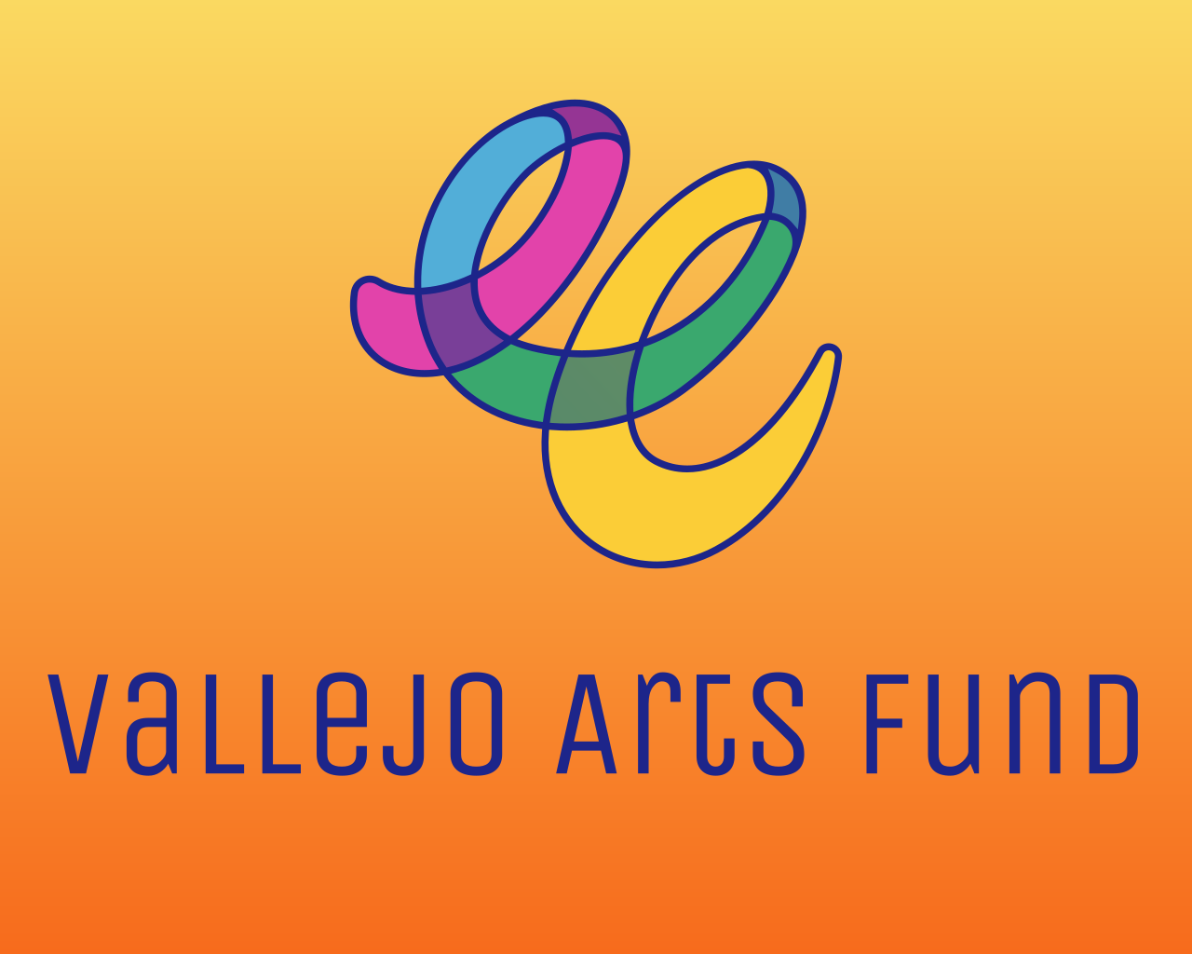
MicroGrants
Application Preview

The Microgrant Application Preview is for REFERENCE ONLY.

The Vallejo Arts Fund will award up to two types of Microgrants in the Winter/Spring 2026 funding round to support artists, cultural bearers, and collectives in expanding their artistic practice, skills, and/or visibility to a broader network, new collaborators, or new audiences.
- Individual Artist Microgrant (Unrestricted): Up to twenty $3,000 awards are available for mid-career or established artists and/or cultural bearers whose body of artistic work, practice, and rootedness in Vallejo provides benefit to the broader community.
- Individual Artist or Artist Collective Microgrant (Program-Restricted): Up to twenty $2,000 awards are available for artists/cultural bearers and/or artist/cultural collectives at all career stages who have been rooted in, working with, or engaging the broader Vallejo community and are seeking funding to support the completion of one artistic or cultural project. Expenses for this project-restricted grant can be spent on artist, producer, and/or venue fees; marketing or publicity; documentation, editing, and archiving; and hospitality for artists or community members, as well as production expenses (i.e., costumes, supplies, or printing).

Note: Please note that although applicants can apply for both unrestricted and program-restricted microgrants, funding will only be awarded within one of these categories. 2023 Micrograntees are ineligible for this grant opportunity.
ELIGIBILITY QUIZ
- Are you 18 years or older?
- Do you reside full-time in California?
- Do you make art or engage in cultural community practices in Vallejo?
- If awarded a grant, are you able to provide proof of identity?
- Are you a Vallejo resident?
  - If yes – If awarded a grant, are you able to provide proof of Vallejo residency?
  - If no – If awarded a grant, are you able to provide proof of California residency?

SECTION 1: CONTACT INFORMATION & APPLICATION DETAILS
- Legal First Name
- Legal Last Name
- OPTIONAL: Other Names (e.g., Stage, Artist, Preferred, or Chosen Name)
- Pronouns
- OPTIONAL: Name of Collective or Group (if applicable)
- Where do you live?
  - North Vallejo
  - East Vallejo
  - South Vallejo
  - West Vallejo
  - Downtown Vallejo
  - Mare Island
  - Outside of Vallejo/Other (Write-in Option)
    - If you selected “Outside of Vallejo/Other (Write-in Option)”, let us know where you live.
- Home Address
- City
- Zip Code
- Email Address
- Daytime Phone Number
- Website URL
- Which discipline best describes your individual or your collective's primary artistic discipline or area of cultural production? (Select One)
  - Options: Animation, Dance; Design; Education; Folk/Traditional Arts; Humanities/Literary Arts; Media Arts; Multidisciplinary; Music; Musical Theatre; Opera; Social Practice; Theatre; Visual Arts; XR (AR/MR/VR)
- OPTIONAL: If the previous list did not fully reflect your individual or your collective’s discipline or area of cultural production, please select the ones that do from the following list:
  - Options: Arts Education; Book Arts; Ceramics; Conceptual Art; Craft; Dance; Design; Digital Technology; DJ-ing; Fiber and Textile Work; Fiction/Non-Fiction Writing; Film/Video; Folk and Traditional Arts; Folklore; Glasswork; Hip Hop; Literary Arts; Media Arts; Digital Media; Metalwork; Multidisciplinary; Multimedia; Mural Making; Music; Musical Theatre; Nonfiction Storytelling; Opera; Painting; Paper and Printmaking; Performance Art; Photography; Poetry; Public Art; Quilting; Regalia Making; Sculpture; Social/Community-Engaged Practices; Spoken Word; Storytelling; Street Art; Theatre; Visual Arts; Woodworking; XR (AR/MR/VR); Write-In Option
    - Write-In Option: If you selected "Write-in Option" with regard to the artistic discipline or area of cultural production of your individual or collective practice, please describe. [25 words max]
- Please provide a direct URL to the website or portfolio where your or your collective’s artistic/cultural work is prominently featured.
Note: The link must be publicly accessible and clearly attributable to you as an applicant or the collective as the applicant. We will not review password-protected or restricted links, links that require login access, or links to private drives (e.g., Google Drive, Dropbox, or OneDrive).
You may include links to a website, press coverage, artist databases (such as IMDb, Artsy, or SoundCloud), or public social media pages (like Instagram, YouTube, or Facebook). The URL must link directly to a page or post that features both your or your collective’s work and name—for example, a specific project page rather than a general profile or homepage.
This link serves as proof of a public-facing artistic, creative, or cultural practice. If we are unable to verify the information provided, your application will be considered incomplete and ineligible for funding.

SECTION 2: VALLEJO RESIDENCY AND ROOTEDNESS
Based on feedback and insights from Vallejoans, the Vallejo Arts Fund honors the importance of individuals, collectives, and organizations being residents of Vallejo and their “rootedness” within the community. The following section seeks to understand the applicant's history of engaging with, working in, and/or rooting their practice in Vallejo.

Please refer to the Rootedness Criteria in the FAQ for more information.

- How long have you been a resident of or has your collective been based in Vallejo?
  - N/A - reside or are based in a city outside of Vallejo
  - Less than six months
  - 6 months-1 year
  - 1-3 years
  - 3-5 years
  - 5-10 years
  - 11+ years
- In which part of Vallejo does the majority of your rooted work take place?
  - North Vallejo
  - East Vallejo
  - South Vallejo
  - West Vallejo
  - Downtown Vallejo
  - Mare Island
  - Other (Write-in Option)
    - If you selected “Other (Write-in Option)”, let us know in which part of Vallejo the majority of your rooted work takes place.
- How long have you or your collective been engaging with, working in, and/or rooting your practice in the Vallejo Arts and Cultural Ecosystem? How is your or your collective’s artistic work or practice informed or impacted by your context in Vallejo? (300 words max)
- Provide a brief statement about the nature of your or your collective's work and practice in Vallejo, the kinds of relationships and/or engagement you have built, including collaborators and/or partnerships. Who and/or which communities have you worked with and/or are working with? Where is your work rooted/engaging/happening in Vallejo? (300 words max)

MICROGRANTS OVERVIEW
The Vallejo Arts Fund will award up to two types of Microgrants in the Winter/Spring 2026 funding round to support artists, cultural bearers, and collectives in expanding their artistic practice, skills, and/or visibility to a broader network, new collaborators, or new audiences.
- Individual Artist Microgrant (Unrestricted): Up to twenty $3,000 awards are available for mid-career or established artists and/or cultural bearers whose body of artistic work, practice, and rootedness in Vallejo provides benefit to the broader community.
- Individual Artist or Artist Collective Microgrant (Program-Restricted): Up to twenty $2,000 awards are available for artists/cultural bearers and/or artist/cultural collectives at all career stages who have been rooted in, working with, or engaging the broader Vallejo community and are seeking funding to support the completion of one artistic or cultural project. Expenses for this project-restricted grant can be spent on artist, producer, and/or venue fees; marketing or publicity; documentation, editing, and archiving; and hospitality for artists or community members, as well as production expenses (i.e., costumes, supplies, or printing).

Note: Please note that although applicants can apply for both unrestricted and program-restricted microgrants, funding will only be awarded within one of these categories. 2023 Micrograntees are ineligible for this grant opportunity.

- Provide a brief one-sentence summary of your request. Begin your summary with "To support..." (65 words max)
Note: The request summary will be used to introduce your application to panelists and should briefly describe your intended use of the unrestricted or project-restricted microgrant (e.g., covering the costs of equipment repair, studio upgrades, artist fees, or professional training). Should you be awarded funding, this summary may be used in your grant contract and public-facing announcements.
- I am applying for:
  - Individual Artist Microgrant (Unrestricted) [Proceed to Section 3a]
  - Individual Artist Microgrant (Program-Restricted) [Proceed to Section 3b]
  - Artist Collective Microgrant (Program-Restricted) [Proceed to Artist Collective Team Member(s), then Section 3b]

[For Artist Collective Microgrant (Program-Restricted) Only]
Artist Collective Team Member(s)
- Provide the name, pronouns, contact information (email and phone number), and role of each additional team member. (100 words)
Note: VAF defines team members as individuals who are core to the collective, its program, and operations.
- Provide brief bios for the team members. (200 words)
- In which parts of Vallejo do the other team members reside? (Select all that apply.)
  - Options: North Vallejo, East Vallejo, South Vallejo, West Vallejo, Downtown Vallejo, Mare Island, Other (Write-in Option)
    - If you selected "Other (Write-in Option)", tell us where the other team members reside. (25 words)
- What role(s) do the other team members play? (Select all that apply.)
  - Options: Lead Teaching Artist; Transformative Justice Counselor; Advisor; Site Liaison; Executive Director; Director of Education; Content Creator; Arts Educator; Mentor; Marketing/Sales; Producer; Videographer/Photographer; Write-in Option
    - If you selected "Write-in Option", tell us the role(s) other team members play. (25 words)
- How long has the team worked together on the program?
  - Options: Less than 1 year; 2-5 years; 6-10 years; 10 years or more
- Have any of the team members, including the lead team member, received a Vallejo Arts Fund grant before?
  - Options: Yes, No, Not Sure
    - If Yes, enter the names of the team member(s) who received a Vallejo Arts Fund grant and the year in which the grant was awarded.

SECTION 3a: INDIVIDUAL ARTIST MICROGRANT
- Artist Statement: Provide a brief artistic statement about your artistic/cultural practice, program/project history, community impact, and your successes. (100 words max)
- Perspective: Describe your role and experience within the arts and culture sector. Your response must include how long you have been in the sector, roles you've held, communities you've supported, and any other factors that have shaped your perspective. Share any first-hand knowledge you bring to the field through your lived, professional, or creative experience. (350 words max)
- Impact: Describe the impact and tangible results of your artistic practice in supporting the broader community of Vallejo and the local arts and culture sector. Highlight the tangible and measurable ways in which historically underresourced communities have been supported by your work in the community. (350 words max)
Note: The support materials submitted must back up the claims made in this section.
- Artistic Context: Provide a brief statement about why a microgrant award now would arrive at a “critical juncture” in your artistic practice or journey. (200 words max)
- Resume: Applicants must upload a brief artist’s résumé, not to exceed one (1) page (.pdf, .doc, and .docx files accepted).
Note: The résumé is a helpful, at-a-glance reference for panelists to familiarize themselves with your experience and activities in the field. Note that Panelists will not review anything beyond one page.

SECTION 3b/c: INDIVIDUAL ARTIST OR ARTISTIC COLLECTIVE MICROGRANT (PROGRAM-RESTRICTED)

- Project Description: Describe the artistic project for which you or your collective is seeking funding. Ensure to provide details with regard to your concept, where in Vallejo it will take place, stage of development, collaborators (if any), timeline, and required resources. (350 words max)
Note: Applications with missing timelines may be considered less competitive.
- Why Now?: Explain how this microgrant arrives at a critical juncture for the work of your collective, and the ways it supports your collective’s growth or experimentation, and why it is important to undertake this project now. (350 words max)
- Location: All Project-Based Microgrant projects must occur within the City of Vallejo. Please let us know where in Vallejo this event will occur. (10 words max)
- Budget: Please provide an outline of how the proposed grant of up to $2,000 will be spent. (250 words max)
Note: For example: $500 on venue, $500 on graphic design, $1000 on artist fees)
- Resume: Applicants must upload a brief artist or artists’ collective résumé, not to exceed one (1) page (.pdf, .doc, and .docx files accepted).
Note: The résumé is a helpful, at-a-glance reference for panelists to familiarize themselves with your experience and activities in the field. Note that panelists will not review anything beyond one page.

SECTION 4: SUPPORT MATERIALS
The following materials are required to verify the applicant’s role(s) in the arts and culture sector, demonstrate that their artistic/cultural practice is public-facing, and provide further context for the action’s direct impact and results within the Vallejo community. Work samples are required and are crucial in helping panelists become familiar with the applicant’s work. Panelists will spend up to five minutes total viewing for each set of requested work samples.

Please check your uploaded support materials to ensure functionality. Applications with inaccessible uploads, such as corrupted or password-protected attachments, will not be reviewed.

For technical assistance (e.g., password or upload issues), request support at: https://www.submittable.com/help/submitter/. Submittable’s business hours are 9 am–5 pm MT. They aim to respond within 24 business hours.

- Upload up to three (3) support materials directly related to the individual artists or artist collectives' artistic and/or cultural work. Examples may include relevant URLs, press, screenshots, or photo/video documentation.
Note: The most helpful materials will demonstrate that the individual artists or artistic collectives' work was impactful and visible within the Vallejo community, and that it was documented in a publicly accessible manner, such as through social media posts, website pages, press releases, etc.

SECTION 5: GRANT ADMINISTRATIVE INFORMATION
If you are recommended and approved for funding, the information requested below will expedite the preparation of your grant contract and the processing of your award payment. We appreciate your support.

Please note that grants can only be released to individuals with a Social Security Number (SSN), Individual Taxpayer Identification Number (ITIN), or organizations with an Employer Identification Number (EIN).

- If you are awarded a grant, who will receive the funds?
  - I will as an individual
  - A non-profit/arts collective will receive the funds.
  - A business will receive the funds.
  - A fiscal sponsor will receive the funds.
  - I’m not sure, please contact me.
- If you have selected that your fiscal sponsor, business, or local nonprofit will be receiving the grant award funds on your behalf, enter the following information about the organization/business and the individual responsible for signing:
Note: If you do not have the full contact information for the fiscal sponsor, business, or local nonprofit/arts collective, fill out what you do know or enter “I don't have this information yet. Please contact me.”
  - Entity (i.e., Business or Nonprofit) Name
  - Entity Address
  - Street
  - City
  - State
  - Zip Code
  - Name of signatory (person who will be signing the grant agreement)
  - Legal First Name
  - Legal Last Name
  - Title of signatory
  - Email address for the person who will sign the grant agreement.
- Bio: Provide a brief bio, including your neighborhood of residence and preferred pronouns. (100 words max)
- Image: Upload a landscape-oriented photograph (2022 or later) that is representative of your work. (jpg, .png, and .pdf file formats accepted)
- Photo Credit: Enter the names of any individuals in the photo (L to R), location, photographer credit, and year.
- Social Media Tags/Website: Please share the social media tags or website where the public can learn more about your work or artistic practice.

SECTION 6: RECOMMENDATIONS AND FEEDBACK
- Do you have recommendations for artists in Vallejo that we should encourage to apply for opportunities at the Vallejo Arts Fund?
  - Options: Yes; No
    - If Yes, please provide their contact information – we’d love to share this opportunity with them!
- On a scale between 1 to 10, how would you rate the accessibility and understandability of this application?
Note: 1 would be the least accessible and understandable, and 10 would be the most.
- Do you have feedback about the application process so far? We welcome any and all feedback.

SECTION 7: DEMOGRAPHIC SURVEY
VAF is committed to distributing resources equally, equitably, and fairly in ways that reflect the diversity of application pools and populations. To that end, we ask you to help us by completing the demographic survey, so we can assemble panels that are representative of the communities we serve. Please know that the information requested below is CONFIDENTIAL and will be used for internal purposes only.

We acknowledge that the criteria and categories presented in this survey may not fully capture all perspectives, and we sincerely welcome your feedback to help us refine them in a more accurate and appropriate manner.

Thank you for your participation.

Response options for the questions below will be available in the online application, including “Prefer Not to State.”

- With which gender(s) do you identify?
- Do you identify as LGBTQIA?
- Do you identify as a person with a disability?
- How do you identify?
- What is your age range?
- What is the highest degree or level of education you have completed?
- Do you owe any student loans currently?
- What is your annual household income?
- What is your career stage?
- Approximate number of years you have been creating art or engaging in cultural practices with the intent to earn income from your work:
- Estimated percentage of income derived from your art/cultural practice or arts-based business:
- Select all the ways in which you try or have tried to raise money.
- Select all the ways in which you have succeeded in raising money.
- How did you hear about this opportunity?

SECTION 8: CERTIFICATION
I certify I have read and met the eligibility requirements stated in the Vallejo Arts Fund - MicroGrants guidelines and that all the information provided in this application is correct to the best of my knowledge. I further acknowledge that the Center for Cultural Innovation (CCI) is not liable for damage or loss of materials submitted.

At any time, if the Center for Cultural Innovation determines that my application is false, misleading, improperly submitted, or fails to further the Vallejo Arts Fund objectives, the Center for Cultural Innovation may, at its sole discretion, deem my application ineligible. Lastly, I agree not to sue the Center for Cultural Innovation if CCI makes such a determination.

[check box] By checking this box, I certify the above to be true.

THANK YOU for your interest and effort in completing this application!!

