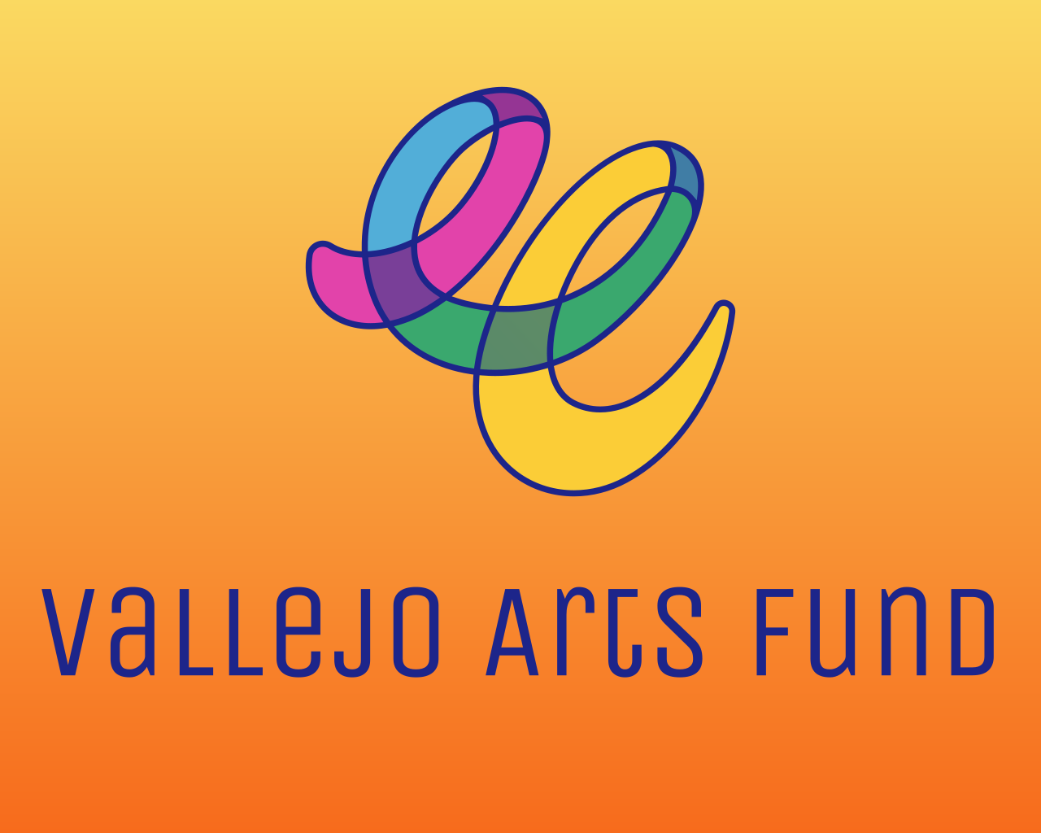
Capacity Building Cohort
Application Preview

The Capacity Building Cohort Grant Application Preview is for REFERENCE ONLY.

The Vallejo Arts Fund will award up to twenty $2,000 grants to individual artists and culture bearers to participate in a Capacity Building Cohort within this grant category. Cohort members will be expected to spend up to 20 hours on cohort capacity-building activities and an additional 20 hours on follow-up, self-directed capacity-building.

ELIGIBILITY QUIZ
- Are you 18 years or older?
- Do you reside full-time in California?
- Do you make art or engage in cultural community practices in Vallejo?
- If awarded a grant, are you able to provide proof of identity?
- Are you a Vallejo resident?
  - If yes – If awarded a grant, are you able to provide proof of Vallejo residency?
  - If no – If awarded a grant, are you able to provide proof of California residency?

SECTION 1: CONTACT INFORMATION & APPLICATION DETAILS
- Legal First Name
- Legal Last Name
- OPTIONAL: Other Names (e.g., Stage, Artist, Preferred, or Chosen Name)
- Pronouns
- Where do you live?
  - North Vallejo
  - East Vallejo
  - South Vallejo
  - West Vallejo
  - Downtown Vallejo
  - Mare Island
  - Outside of Vallejo/Other (Write-in)
    - If you selected “Outside of Vallejo/Other (Write-in Option)”, let us know where you live.
- Home Address
- City
- Zip Code
- Email Address
- Daytime Phone Number
- Website URL
Note: Please provide a direct URL to the website or portfolio where your individual, collective, and/or organizational artistic and/or cultural works are prominently featured.
The link must be publicly accessible and clearly attributable to the applicant (individual, collective, or organization). We will not review password-protected or restricted links, links that require login access, or links to private drives (e.g., Google Drive, Dropbox, or OneDrive).
You may include links to a website, press coverage, artist databases (such as IMDb, Artsy, or SoundCloud), or public social media pages (like Instagram, YouTube, or Facebook). The URL must link directly to a page or post that features both your individual, collective, or organization’s work and name—for example, a specific project page rather than a general profile or homepage.
This link serves as proof of a public-facing artistic, creative, or cultural practice. If we are unable to verify the information provided, your application will be considered incomplete and ineligible for funding.
- Which discipline best describes your individual primary artistic discipline or area of cultural production? (Select One)
  - Options: Animation, Dance; Design; Education; Folk/Traditional Arts; Humanities/Literary Arts; Media Arts; Multidisciplinary; Music; Musical Theatre; Opera; Social Practice; Theatre; Visual Arts; XR (AR/MR/VR)
- OPTIONAL: If the previous list did not fully reflect your discipline or area of cultural production, please select the ones that do from the following list:
  - Options: Arts Education; Book Arts; Ceramics; Conceptual Art; Craft; Dance; Design; Digital Technology; DJ-ing; Fiber and Textile Work; Fiction/Non-Fiction Writing; Film/Video; Folk and Traditional Arts; Folklore; Glasswork; Hip Hop; Literary Arts; Media Arts; Digital Media; Metalwork; Multidisciplinary; Multimedia; Mural Making; Music; Musical Theatre; Nonfiction Storytelling; Opera; Painting; Paper and Printmaking; Performance Art; Photography; Poetry; Public Art; Quilting; Regalia Making; Sculpture; Social/Community-Engaged Practices; Spoken Word; Storytelling; Street Art; Theatre; Visual Arts; Woodworking; XR (AR/MR/VR); Write-In Option
    - Write-In Option: If you selected "Write-in Option" with regard to the artistic discipline or area of cultural production of your individual practice, please describe. [25 words max]

SECTION 2: VALLEJO RESIDENCY AND ROOTEDNESS
Based on feedback and insights from Vallejoans, the Vallejo Arts Fund honors the importance of individuals, collectives, and organizations being residents of Vallejo and their “rootedness” within the community. The following section seeks to understand the applicant's history of engaging with, working in, and/or rooting their practice in Vallejo.
Please refer to the Rootedness Criteria in the FAQ for more information.

- How long have you been a resident of Vallejo?
  - N/A - reside or are based in a city outside of Vallejo
  - Less than six months
  - 6 months-1 year
  - 1-3 years
  - 3-5 years
  - 5-10 years
  - 11+ years
- In which part of Vallejo does the majority of your rooted work take place?
  - North Vallejo
  - East Vallejo
  - South Vallejo
  - West Vallejo
  - Downtown Vallejo
  - Mare Island
  - Other (Write-in Option)
    - If you selected “Other (Write-in Option)”, let us know in which part of Vallejo the majority of your rooted work takes place.

- How long have you been engaging with, working in, and/or rooting your practice within the Vallejo Arts and Cultural Ecosystem? How is your individual artistic work or practice informed by or impacted by your context in Vallejo? (300 words max)
- Provide a brief statement about the nature of your work and practice in Vallejo, the kinds of relationships and/or engagement you have built, including collaborators and/or partnerships. Who and/or which communities have you worked with and/or are working with? Where is your work rooted/engaging/happening in Vallejo? (300 words max)

CAPACITY BUILDING GRANTS OVERVIEW
The Vallejo Arts Fund will award up to twenty $2,000 grants to individual artists and culture bearers to participate in a Capacity Building Cohort within this grant category. Cohort members will be expected to spend up to 20 hours on cohort capacity-building activities and an additional 20 hours on follow-up, self-directed capacity-building.

SECTION 3: CAPACITY BUILDING INFORMATION
- Tell us why you are applying to be a part of the Capacity Building Grant? What are you interested in learning from this process? Why is this the right time for you to participate in this Capacity Building Cohort? (300 words max)

- The cohort will also have time in small teams to plan, produce, and evaluate a public capacity-building workshop. What kind of capacity-building workshop(s), topic(s), or opportunities do you think that Vallejoans need right now? What are you interested in helping to grow? (300 words max)

SECTION 4: SUPPORT MATERIALS
The following materials are required to verify the applicant’s role(s) in the arts and culture sector, demonstrate that their artistic/cultural practice is public-facing, and provide further context for the action’s direct impact and results within the Vallejo community. Work samples are required and are crucial in helping panelists become familiar with the applicant’s work. Panelists will spend up to five minutes total viewing for each set of requested work samples.

Please check your uploaded support materials to ensure functionality. Applications with inaccessible uploads, such as corrupted or password-protected attachments, will not be reviewed.

For technical assistance (e.g., password or upload issues), request support at: https://www.submittable.com/help/submitter/. Submittable’s business hours are 9 am–5 pm MT. They aim to respond within 24 business hours.
- Upload up to three (3) support materials directly related to the individual’s artistic and/or cultural work. Examples may include relevant URLs, press, screenshots, or photo/video documentation.
Note: The most helpful materials will demonstrate that the individual artists or artistic collectives' work was impactful and visible within the Vallejo community, and that it was documented in a publicly accessible manner, such as through social media posts, website pages, press releases, etc.

SECTION 5: GRANT ADMINISTRATIVE INFORMATION
If you are recommended and approved for funding, the information requested below will expedite the preparation of your grant contract and the processing of your award payment. We appreciate your support.

Please note that grants can only be released to individuals with a Social Security Number (SSN), Individual Taxpayer Identification Number (ITIN), or organizations with an Employer Identification Number (EIN).

- If you are awarded a grant, who will receive the funds?
  - I will as an individual
  - A non-profit/arts collective will receive the funds.
  - A business will receive the funds.
  - A fiscal sponsor will receive the funds.
  - I’m not sure, please contact me.
- If you have selected that your fiscal sponsor, business, or local nonprofit will be receiving the grant award funds on your behalf, enter the following information about the organization/business and the individual responsible for signing:
Note: If you do not have the full contact information for the fiscal sponsor, business, or local nonprofit/arts collective, fill out what you do know or enter “I don't have this information yet. Please contact me.”
  - Entity (i.e., Business or Nonprofit) Name
  - Entity Address
  - Street
  - City
  - State
  - Zip Code
  - Name of signatory (person who will be signing the grant agreement)
  - Legal First Name
  - Legal Last Name
  - Title of signatory
  - Email address for the person who will sign the grant agreement.
- Bio: Provide a brief bio, including your neighborhood of residence and preferred pronouns. (100 words max)
- Image: Upload a landscape-oriented photograph (2022 or later) that is representative of your work. (jpg, .png, and .pdf file formats accepted)
- Photo Credit: Enter the names of any individuals in the photo (L to R), location, photographer credit, and year.
- Social Media Tags/Website: Please share the social media tags or website where the public can learn more about your work or artistic practice.
SECTION 6: RECOMMENDATIONS AND FEEDBACK
- Do you have recommendations for artists in Vallejo that we should encourage to apply for opportunities at the Vallejo Arts Fund?
  - Options: Yes; No
    - If Yes, please provide their contact information – we’d love to share this opportunity with them!
- On a scale between 1 to 10, how would you rate the accessibility and understandability of this application?
Note: 1 would be the least accessible and understandable, and 10 would be the most.
- Do you have feedback about the application process so far? We welcome any and all feedback.

SECTION 7: DEMOGRAPHIC SURVEY
VAF is committed to distributing resources equally, equitably, and fairly in ways that reflect the diversity of application pools and populations. To that end, we ask you to help us by completing the demographic survey, so we can assemble panels that are representative of the communities we serve. Please know that the information requested below is CONFIDENTIAL and will be used for internal purposes only.

We acknowledge that the criteria and categories presented in this survey may not fully capture all perspectives, and we sincerely welcome your feedback to help us refine them in a more accurate and appropriate manner.

Thank you for your participation.

Response options for the questions below will be available in the online application, including “Prefer Not to State.”

- With which gender(s) do you identify?
- Do you identify as LGBTQIA?
- Do you identify as a person with a disability?
- How do you identify?
- What is your age range?
- What is the highest degree or level of education you have completed?
- Do you owe any student loans currently?
- What is your annual household income?
- What is your career stage?
- Approximate number of years you have been creating art or engaging in cultural practices with the intent to earn income from your work.
- Estimated percentage of income derived from your art/cultural practice or arts-based business.
- Select all the ways in which you try or have tried to raise money.
- Select all the ways in which you have succeeded in raising money.
- How did you hear about this opportunity?

SECTION 8: CERTIFICATION
I certify I have read and met the eligibility requirements stated in the Vallejo Arts Fund - Capacity Building guidelines and that all the information provided in this application is correct to the best of my knowledge. I further acknowledge that the Center for Cultural Innovation (CCI) is not liable for damage or loss of materials submitted.

At any time, if the Center for Cultural Innovation determines that my application is false, misleading, improperly submitted, or fails to further the Vallejo Arts Fund objectives, the Center for Cultural Innovation may, at its sole discretion, deem my application ineligible. Lastly, I agree not to sue the Center for Cultural Innovation if CCI makes such a determination.

[check box] By checking this box, I certify the above to be true.

THANK YOU for your interest and effort in completing this application!!

